Contents

**PATH variable** 1

• **To display value of PATH variable** 1

• **To split PATH variable in simple readable format** 1

• **To add new path permanently in PATH variable** 1

• **Command not found: error** 2

**PATH variable**:

* When user types a command, OS will search executable files of the issued command in some predefined place. This place is called PATH.
* PATH variable holds all predefined locations as a value.
* PATH variable is an environmental variable.
* **To display value of PATH variable**,

Command: echo $PATH



* **To split PATH variable in simple readable format**,

Command: echo $PATH | tr ':' '\n'

Example:

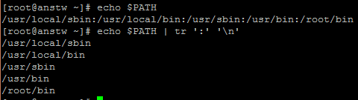

Here, OS will look for executable files in same order (from left to right), 1st /usr/local/sbin to last /root/bin.

* In case, you store executable files of some programs other than mentioned paths by PATH variable and you want to install programs without specifying its exact location each time then it can be done by adding that exact location to $PATH.

Command: **export PATH=$PATH:**/new/directory/path



But this will not work in other terminals or if system is rebooted.

* **To add new path permanently in PATH variable**,
* Add following command in **~/.bash_profile** or ~/.bashrc file.

**export PATH=$PATH:**/new/directory/path

It will add new path to end of PATH(last).

**export PATH=**/new/directory/path **:$PATH**

It will add new path to the beginning of PATH(first).

* After adding path, source the file by following command,

Command: source ~/.bash_profile

* To verify it, open new terminal and check with echo $PATH. New added path should be appeared in PATH variable.

## **Command not found: error**

* Make sure program is installed.
* If program is installed then, OS isn’t able to find its executable file in PATH variable.
* To find executable file location,

Command: **whereis** <command name>

Command: which <command name>

* Add executable file location in PATH variable permanently.
* Reference:

<http://www.golinuxhub.com/2012/09/bash-command-not-found.html>